**Challenge : L0Ck_Web**

**Solution :**

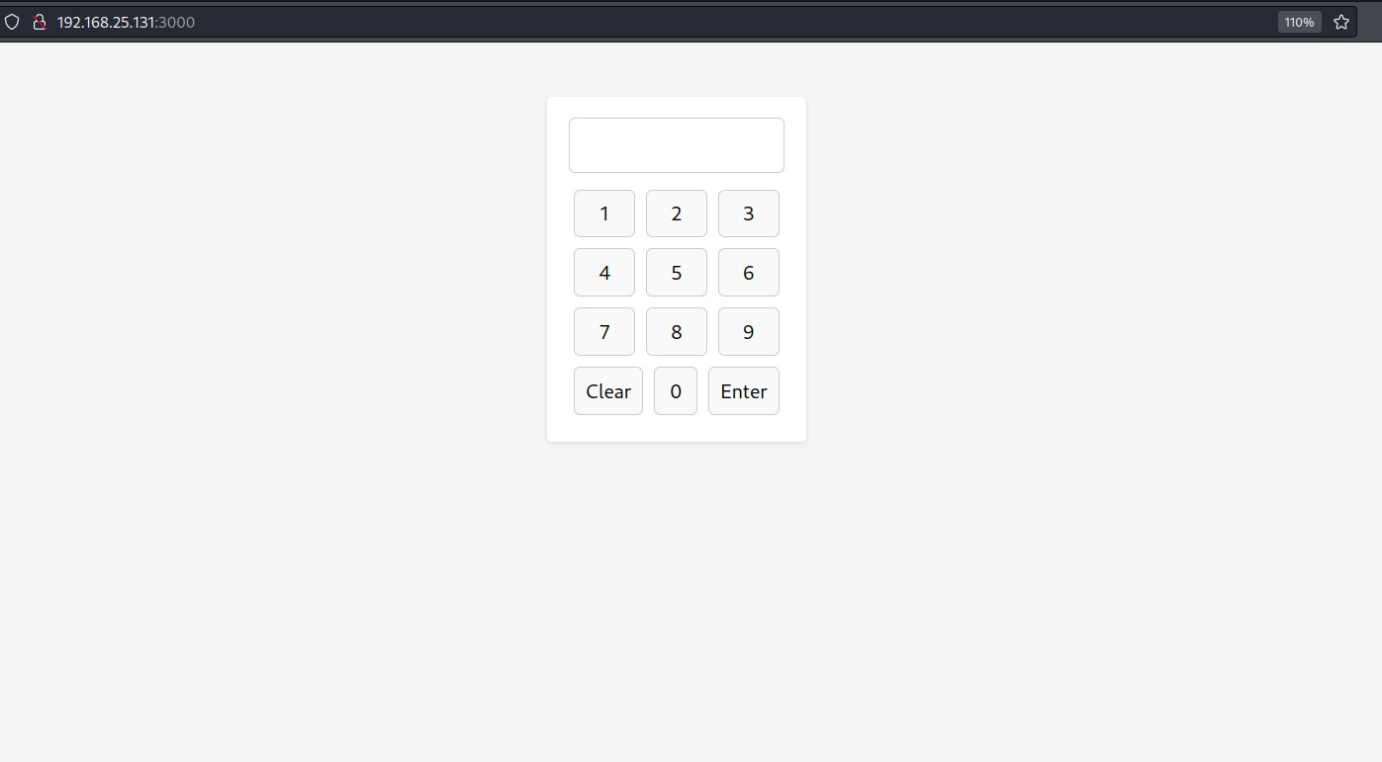

The basic disallowed subdomains are in the robots.txt .

Pin is Base36 encoded first decode it

And Pin = 1928

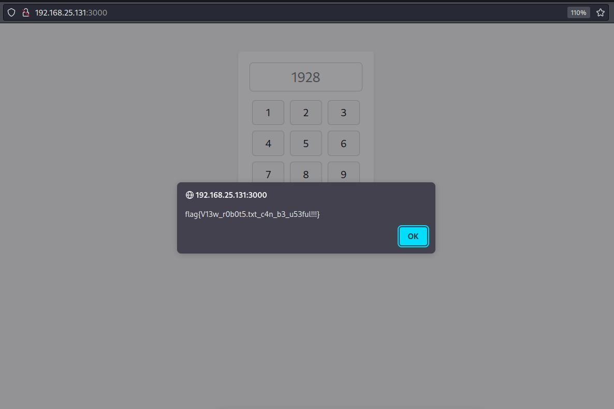

Flag : flag{V13w_r0b0t5.txt_c4n_b3_u53ful!!!}